2013-2014学年度第二学期六年级期末考试试卷

题 号 |  | 一 | 二 |  | 三 | 四 | 五 | 六 | 七 | 八 | 九 | 十 | 十一 | 总分
得 分 |  |  |  |  |  |  |  |  |  |  |  | [来源:学。科。网]
总分人 |  |  |  |  |  |  |  | [来源:学。科。网]
评卷人 | 得分
 | [来源:学#科#网Z#X#X#K]

第一部分 听力（30分
一、听录音，选出与录音相符合的一项，并将其字母编号填在题前的括号里。（10分）
( )1 A boy B ball C bored
( )2 A shop B short C ship
( )3 A book B look C took
( )4 A singing B sang C song
( )5 A fail B fall C feel
( )6 A On Feb.2nd B On Feb.12th C On Feb.20th
( )7 A Children’Day B Women’s Day C Teacher’s Day
( )8 A He had a fever. B He had the flu. C He had a cold
( )9 A Zhang Peng went to school by bus.
B Zhang Peng went school by subway.
C Zhang Peng went to school by bike.
( )10 A What did you do in the morning?
B What do you do in the morning?
C What are you going to do in the morning?

评卷人 | 得分
二、听录音，判断图片是否与录音内容相符，相符的在括号内打“√”，不相符的打“×”。（5分）
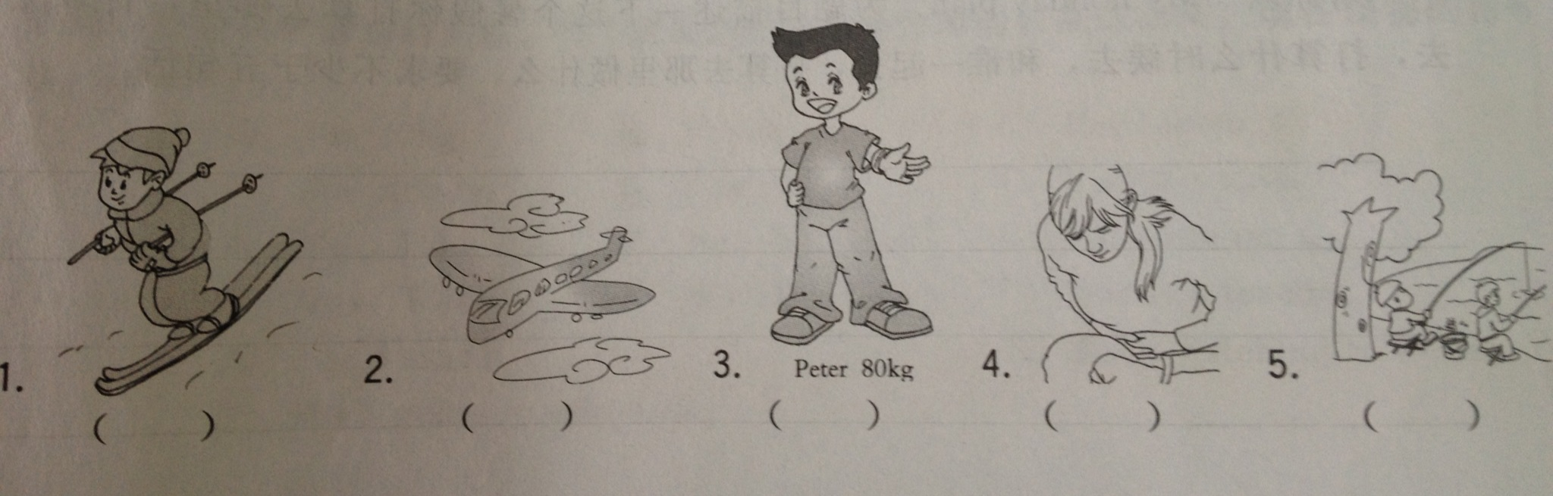
评卷人 | 得分
三、根据你在录音中听到的问题，将下面每组答句中最合适的答案选出来，并将其字母编号填在题前的括号里。（10分）
( )1 A Yes, I know. B No,I am not. C Yes,I do.
( )2 A Tomorrow. B Tomorrow C Yes, I do.
( )3 A I was tall. B I was happy. C I was eight.
( )4 A She went to a village.
B We went fishing yesterday.
C They went to a park.
( )5 A It was sunny. B It was Sunday. C It is the sun.
评卷人 | 得分
四、根据录音内容填写下列句子中所缺的单词，使句子完整，每空只填一词（5分）
1．We music on Monday.
2. We went ______ in a park.
3. Do you like _______ boats?
4. Amy ______ a big mouse yesterday.
5. John ________ to Shanghai on Friday.
第二部分 笔试 （70分）

评卷人 | 得分
五、选出每组中发音不同的单词。（5分）
( )1. A. out B. about C. should D. round
( )2. A. tower B. flower C. cow D. grow
( )3. A. jumped B. played C. kicked D. walked
( )4. A. night B. sight C. right D. eight
( )5. A. learn B. near C. hear D. dear
评卷人 | 得分
六、单项选择。（20分）
( )1.What day it yesterday?
A was B is C were D be
( )2. I was born May 4th.
A in B at C on D with
( ) 3. I learn a lot by things.
A make B makes C made D making
( ) 4.He to the park last Sunday.
A go B goes C went D going
( )5. people visit Beijing every year.
A Thousand B Thousands C Thousands of D Thousand of
( )6. He is _____ in watching TV.
A. interest B. interesting C. interested D. interests
( ) 7. What time did your mother ____ home yesterday ?
A. get B. get to C. got D. got to
( ) 8. There is only ____ tea in the cup.
A. a few B. few C. little D. many
( ) 9. We shouldn’t cut down ___ trees or waste ___ water.
A. too many, too much B. too much, too many
C. too much, too much D. too many ,too many
( ) 10. The teacher always tells us ____ the rules of our school.
A. obey B. to obey C. obeying D. obeyed
评卷人 | 得分
 | [来源:Zxxk.Com]
七、按要求改写句子。（10分）
1. I did my homework yesterday evening. (改为否定句)
I ______ ______ my homework yesterday evening.
2. He goes to school by bike every day.（对划线部分提问）
______ ______ he ______ to school every day?
3. He will go to Shanghai by train. （改为同义句）
He will ______ ______ ______ to Shanghai.
4. The new supermarket is next to the computer store. （对划线部分提问）
______ ______ the new supermarket?
评卷人 | 得分
八、填序号完成对话。（5分）
Amy:______________________
Jenny: I went to Xinjiang.
Amy: _____________________
Jenny: Yes, it is very far. We flew to Xinjiang.
Amy: Oh! ____________
Jenny: We sang and dance with our friends. And we ate many delicious fruits.
Amy: It sounds great!
Jenny: ______________
Amy：It was interesting . I went to HongKong on my holiday.
Jenny: __________
Amy：Of course! I like the Disney Park very much.
- Where did you go in Hong Kong?
- How was your holiday, Amy?
- Is it far from Guangzhou?
- How did you go there?
- What did you do there?
- Where did you go on your holiday?
- Did you go to the Disney Park?
评卷人 | 得分
九、阅读理解（10分）
Hello, I’m Mike. I went to Hainan with my parents during the winter holiday. Everyone asked us to bring some T-shirts to Hainan, because it was very hot in Hainan. So we took many T-shirts and shorts with us. This winter, it was so strange(奇怪的). The weather was not fine. It was always cloudy and rainy, and it was very cold. But we only had T-shirts and shorts. We didn’t take one coat or sweater. So we stayed in the restaurant. We went back four days later. We didn’t visit any places in Hainan. It was really a terrible trip.
( ) 1. Where did Mike go duriing the winter holiday? He went to ______.
A. Beijing B. Hainan C. Xinjiang
( ) 2. Did they take any sweaters?
A. Yes, they did. B. No, they didn’t. C. They forgot.
( ) 3. What was the weather like in Hainan this holiday? It was ______.
A. good B. hot C. bad
( ) 4. What did they do in Hainan? They _____.
A. visited many beautiful places B. took a trip C. stayed in the room
( ) 5. What does “terrible” meam ? It means “_______”.
A. very good B. OK C. very bad
评卷人 | 得分
十、选词填空，使短文的内容完整。（10分）
Went got took bought skiing swimming for trip teach in tired first

I had a _____ to Shenzhen. On the _____ day, I_____ to the Window of the World. I_____ many pictures ________ the park. On the second day, I went ________. I didn’t know how to ski.I asked someone to ________ me. On the third day, I went shopping. I _______ many beautiful presents ________ my friends. I was ________. I wanted to have a rest.

评卷人 | 得分
十一、写作。（10分）
请你以“My holiday plan”为题描述一下这个暑假你打算去哪里，打算怎样去，打算什么时间去，和谁一起去，打算去那里做什么。要求不少于5句话。
听力稿及答案
一、1.I feel bored yesterday.
2. My skirt is very short.
3. The cook is reading a book.
4.Look! The birds are singing in the tree.
5. Kitty looks sad, and she hurts her leg, too. She must fall down from her bike yesterday.
6. My math teacher’s birthday is on Feb. 20th.
7. Today is March 8th. What holiday is it?
8. –What’s the matter with Tom ? He looks sick. –He had a cold.
9. –How did you go to school yesterday, Zhang Peng? -- I went by bike.
10. What do you do in the morning?
二、1. Tom is skiing.
2. I went to my aunt’s home by train last winter holiday.
3. Peter is the shortest student in our class. He is 80cm.
4. Chen Jie is sick today. She has a toothache.
5. They are fishing by the river.
三、1. Do you know your art teacher’s English name?
2. When did you take this picture?
3. How did you feel just now?
4. What ded you do yesterday?
5. What was the weather like last Sunday?
四、1. We learned music on Monday.
2. We went hiking in a park.
3. Do you like rowing boats?
4. Amy saw a big mouse yesterday.
5. John got to Shanghai on Friday.

答案：
一、CBAAB CBCCB
二、VXXXV
三、CCBBA
四、learned, hiking, rowing, saw, got.
五、CDBDA
六、ACDCC CACAB
七、1. didn’t do 2. How does, go 3. take a train 4. Where is
八、FCEBG
九、BBCCC
十、 trip, first, went, took, in, skiing, teach, bought, for, tired.
十一、范文略

